## Part b - Building a fraud detection model with AutoML

In this document, there will be screenshots of

* Upload a Managed Dataset to Vertex AI
* Train a model with AutoML
* Deploy the trained AutoML model to an endpoint and use that endpoint to get predictions

1. Create a notebook instance

2. Creating a dataset and importing from BigQuery

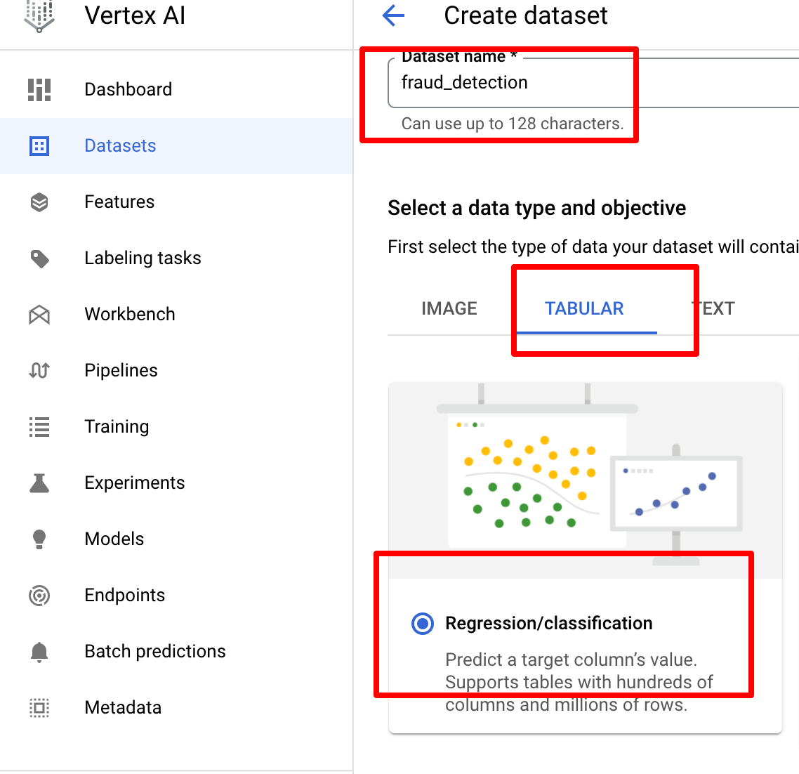

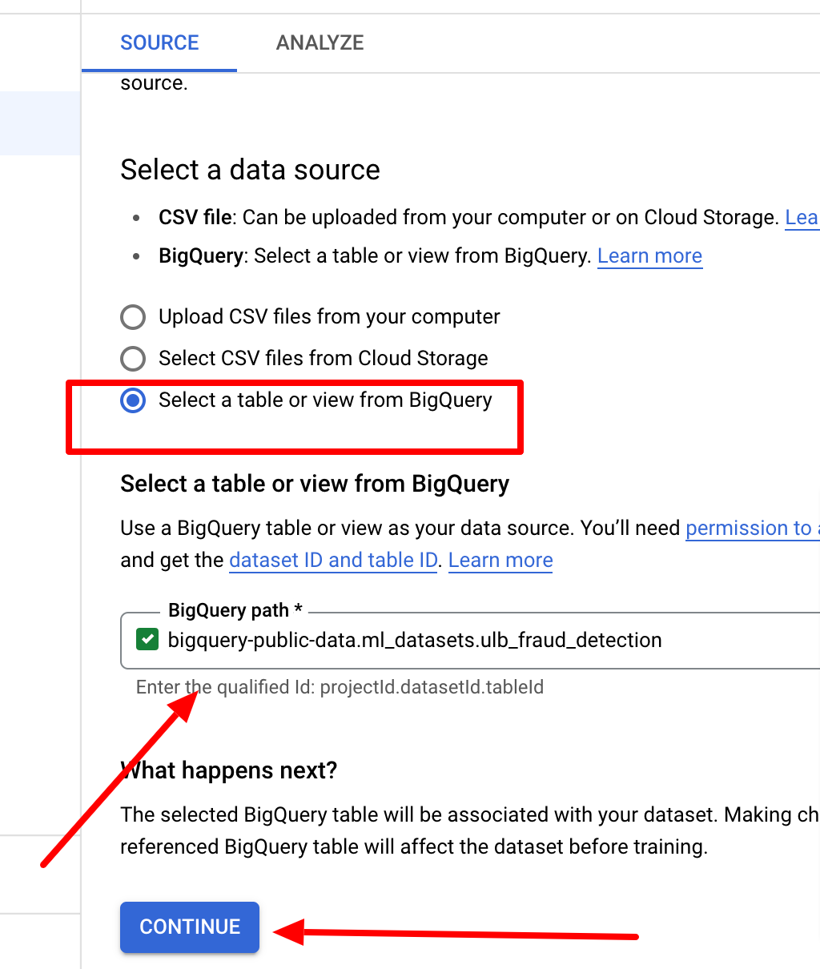

3. Analyzing dataset gives details about the variables

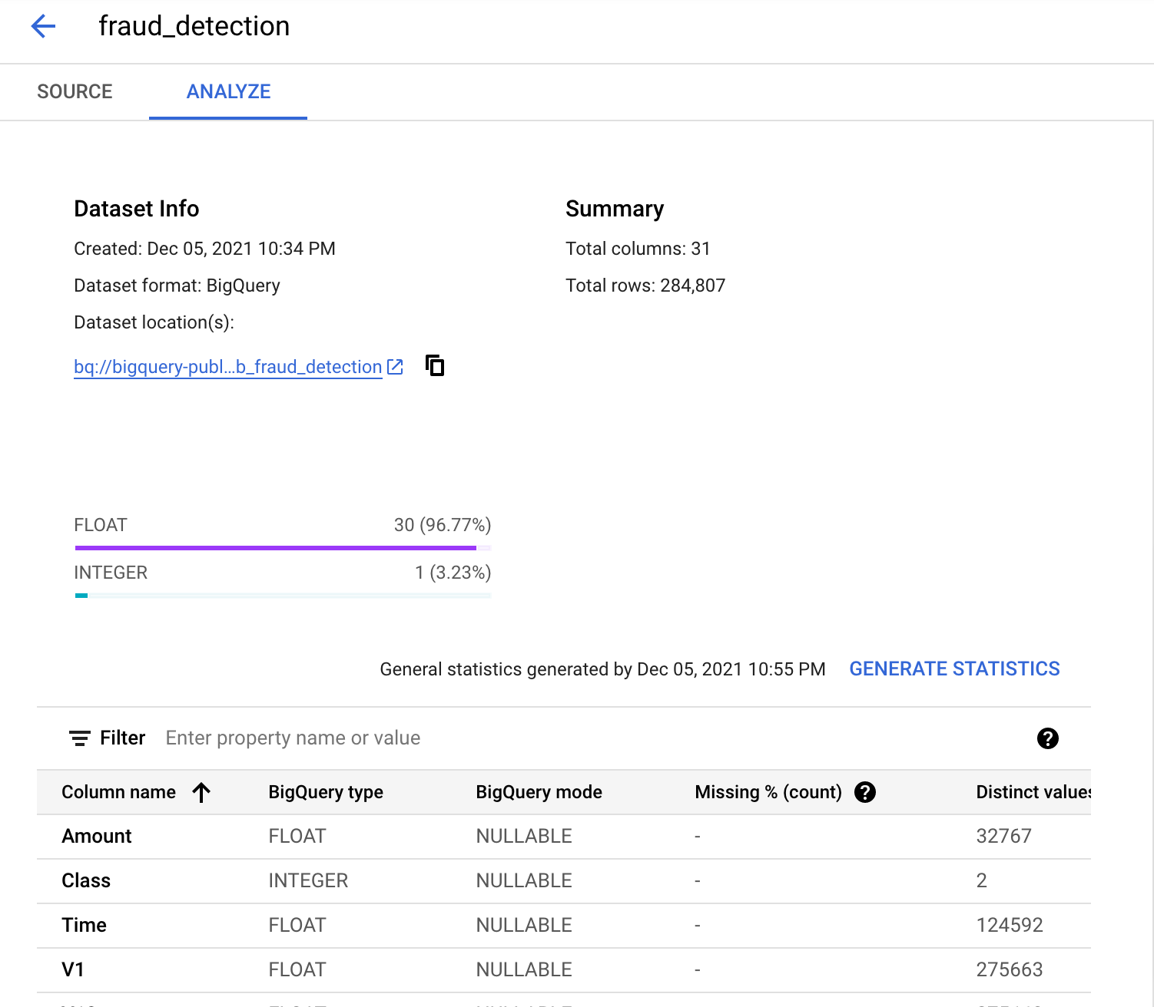

4. Training the model using AutoML

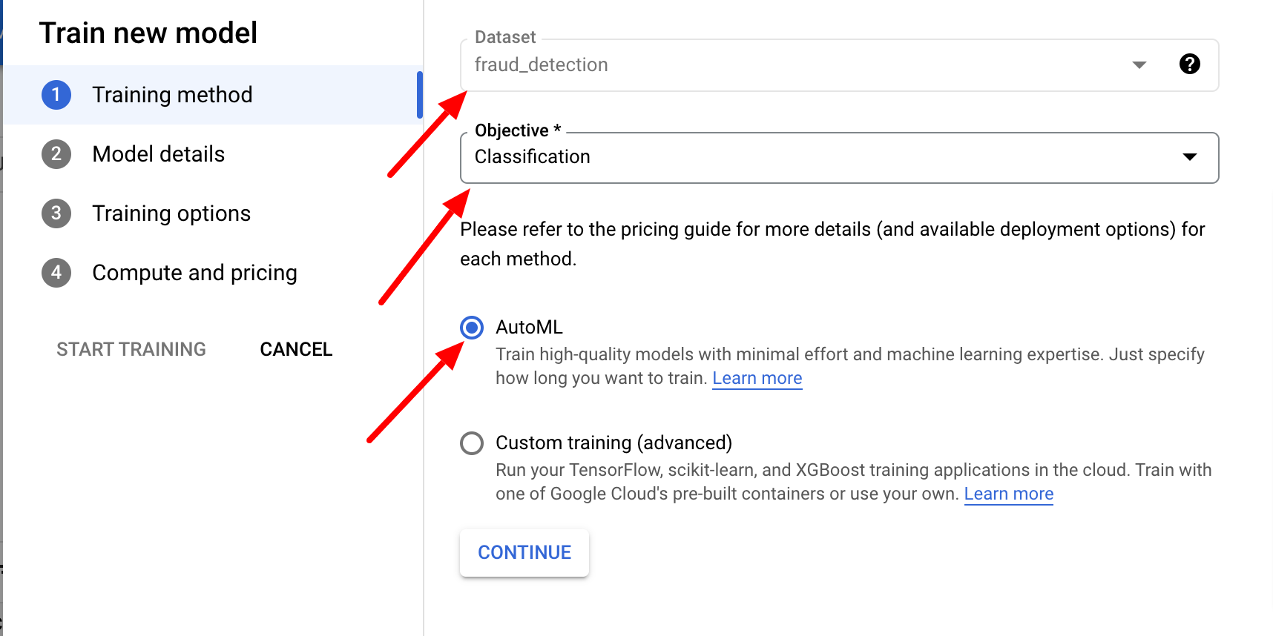

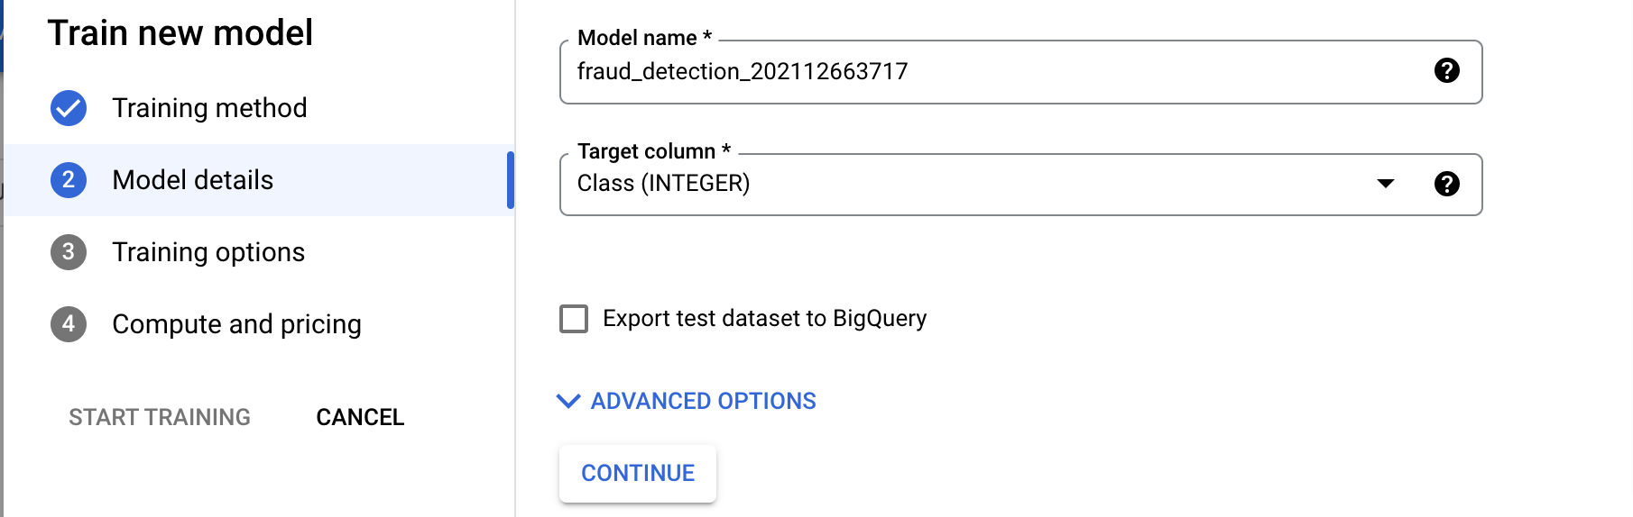

Model specifications

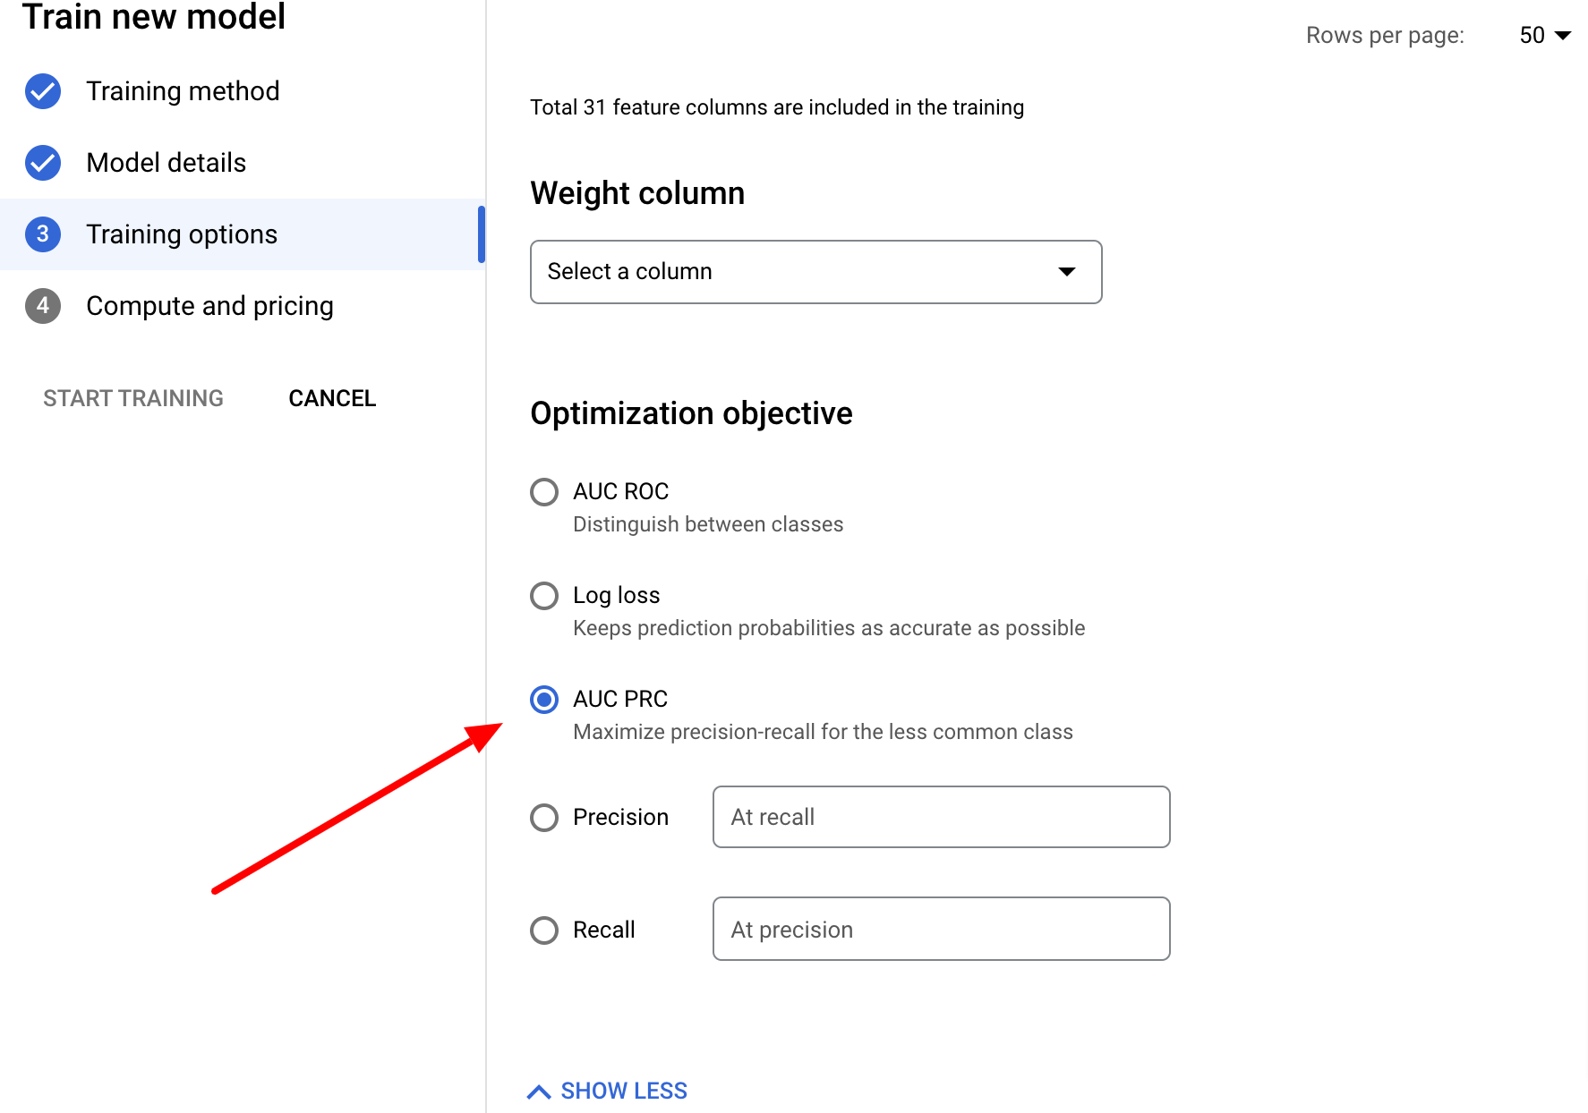

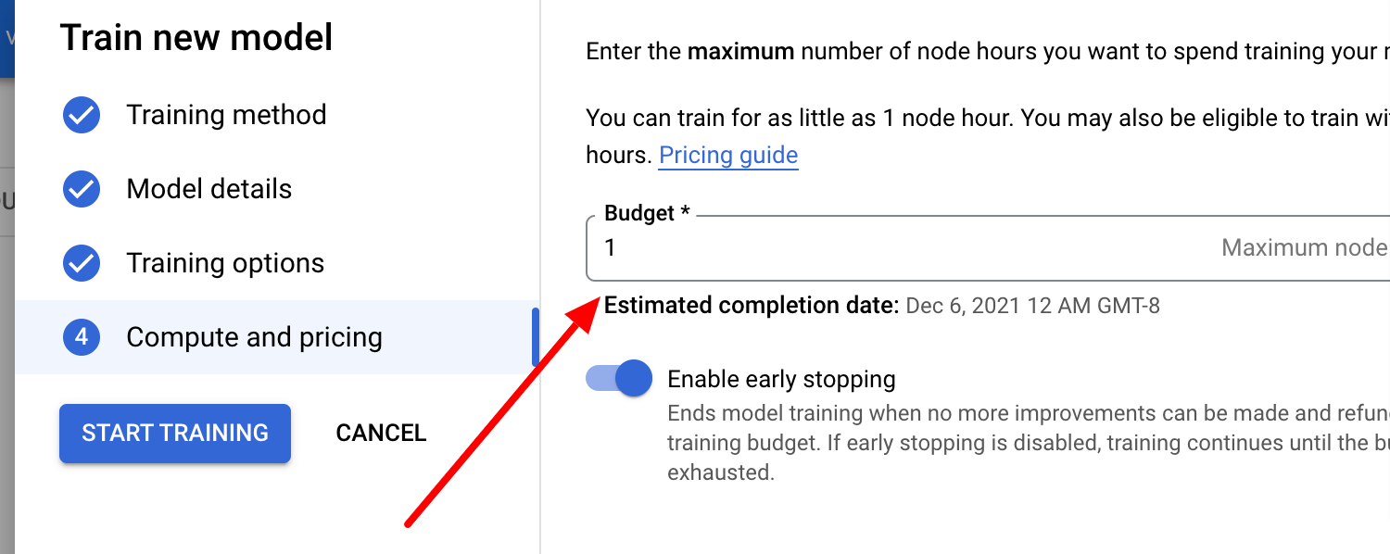

5. Model Evaluation:

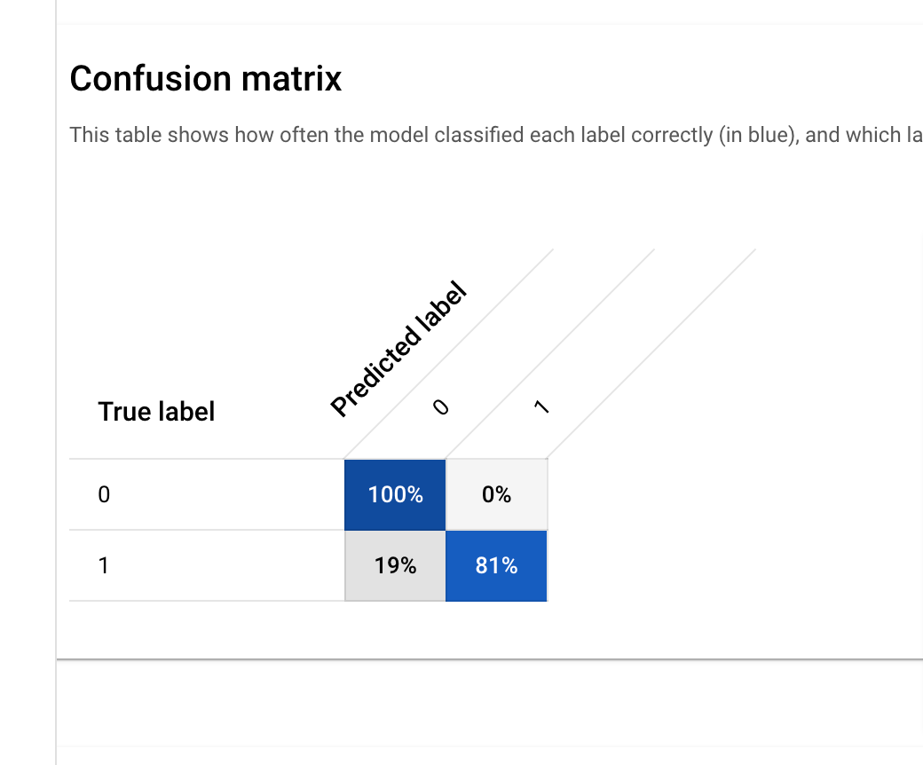

Feature Importance:

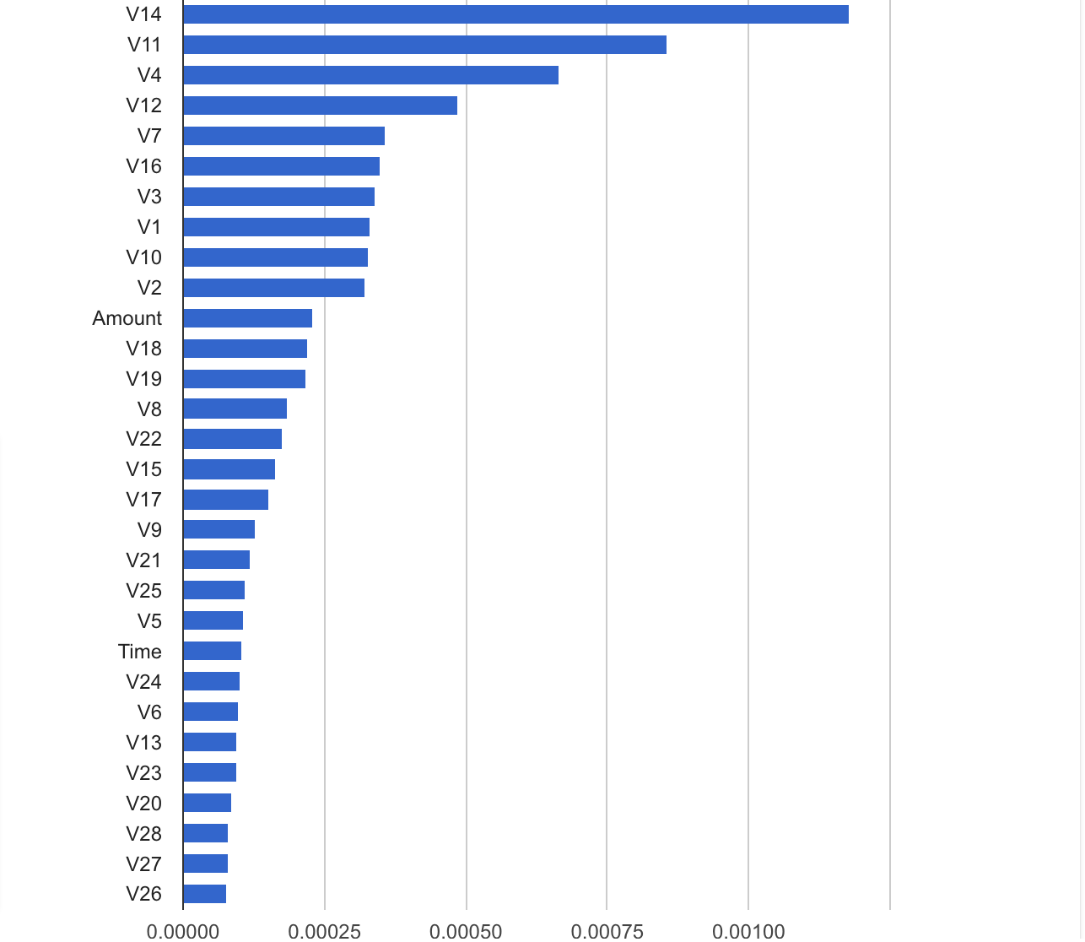

6. Deploying trained model to endpoint

Deploying to an endpoint

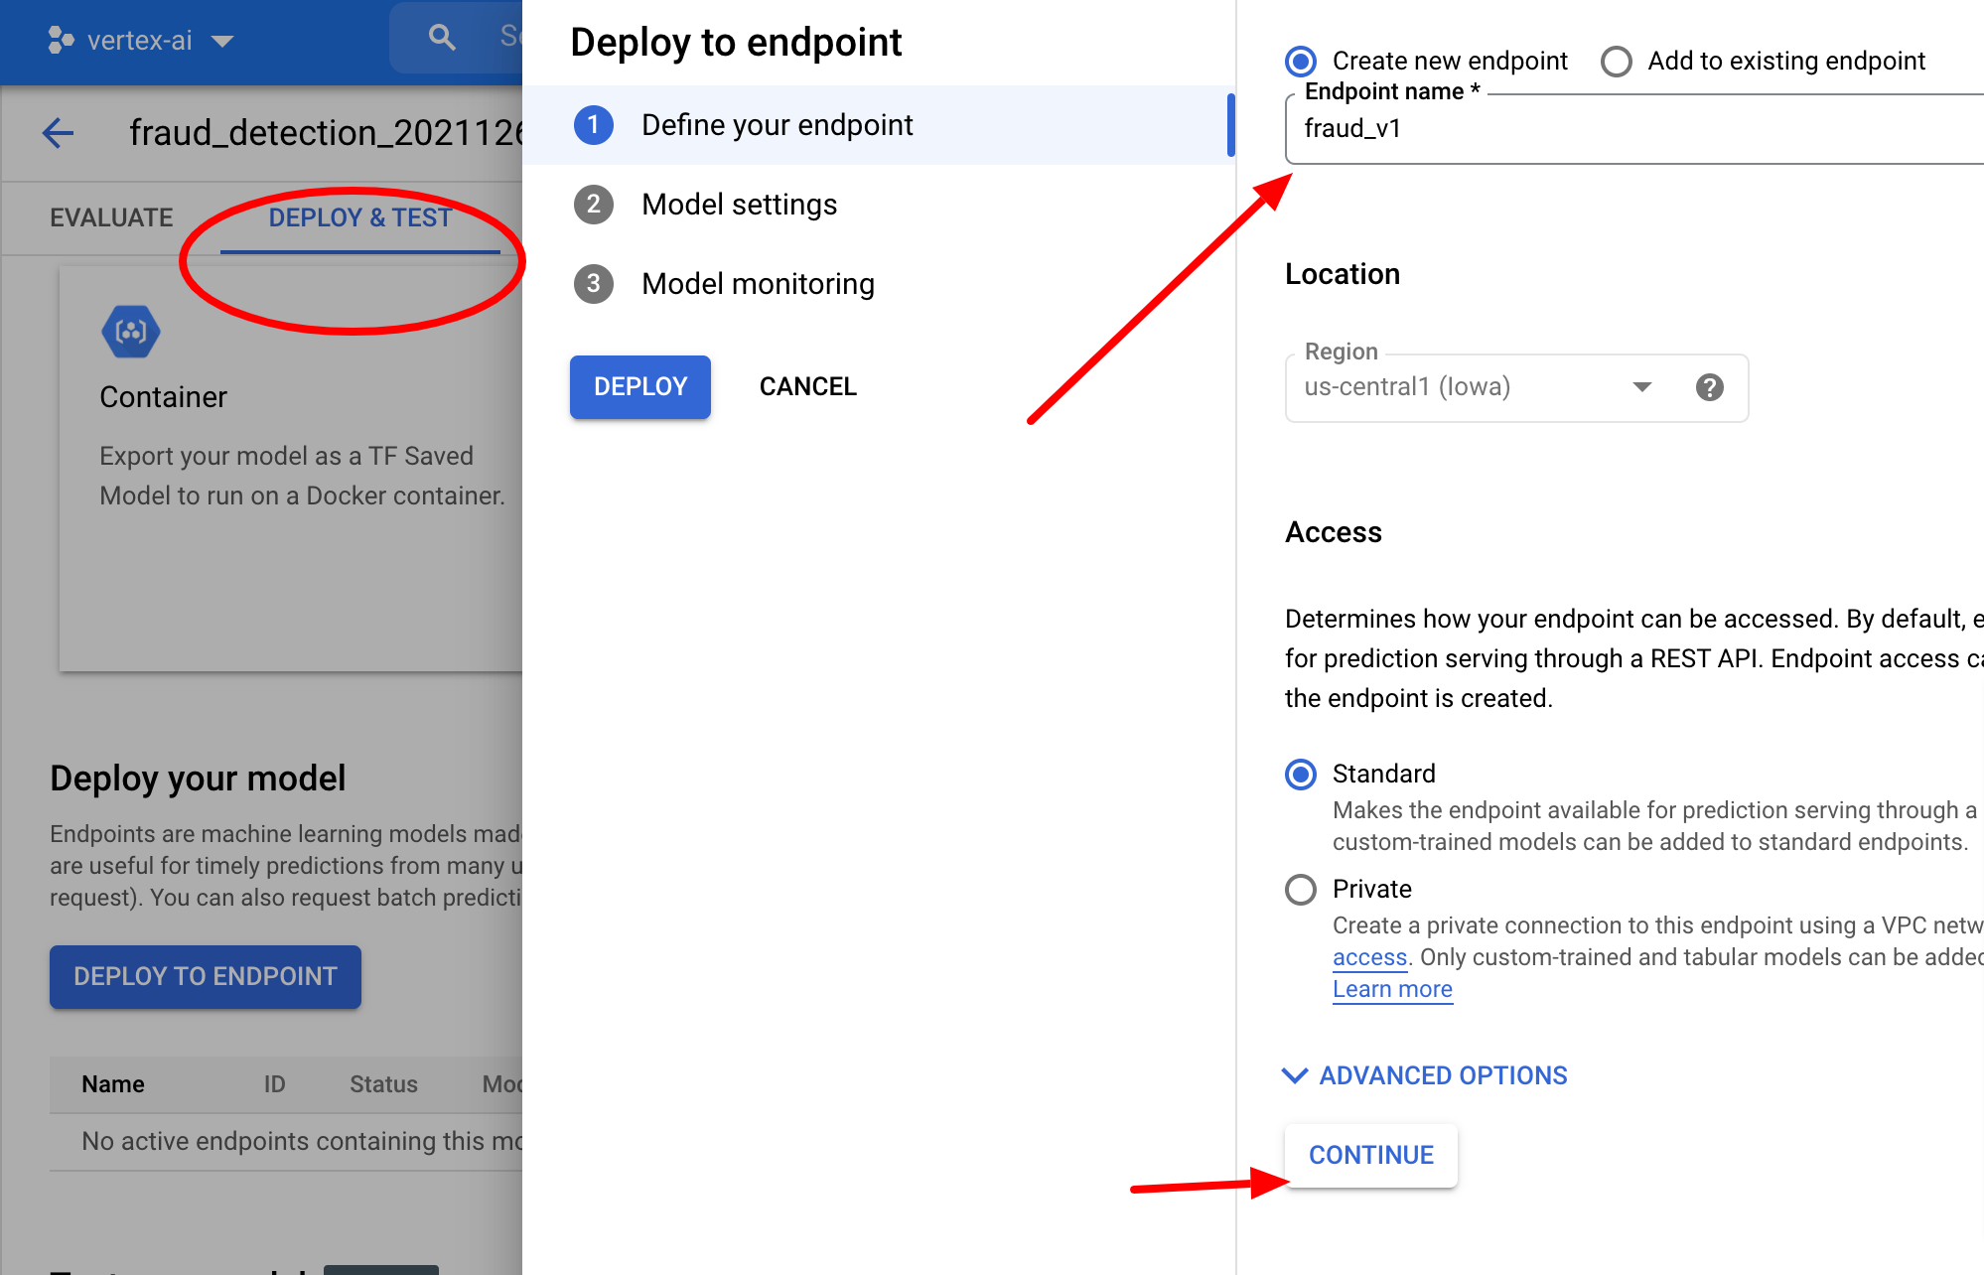

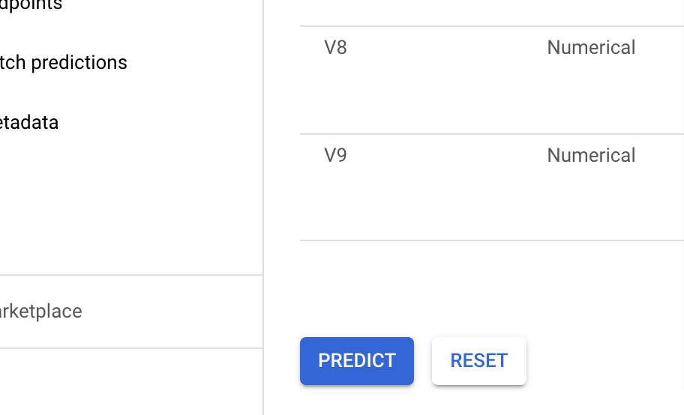

Prediction can viewed on GUI

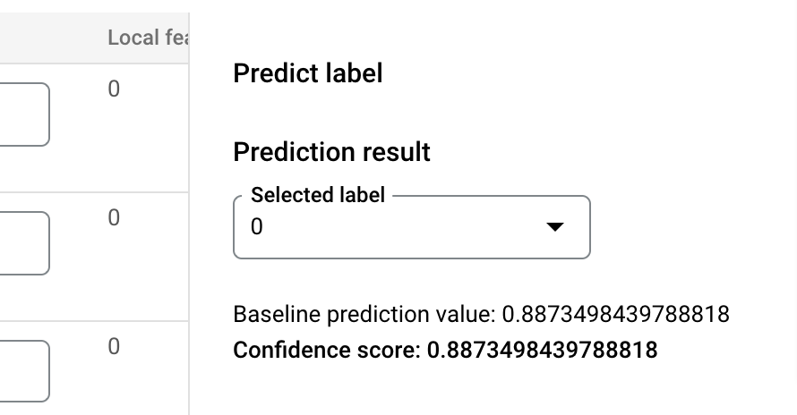

Deploying to a REST API

Endpoint

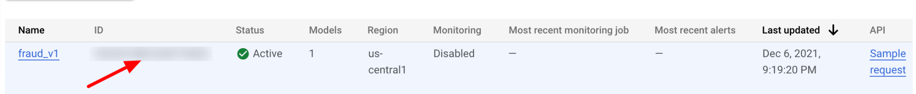

Testing the model endpoint

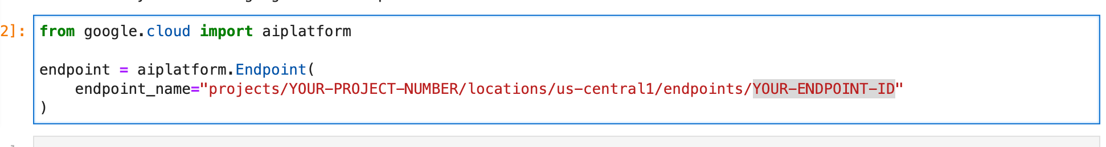

Prediction